SAURABH JOSHI

7249

SE COMP B

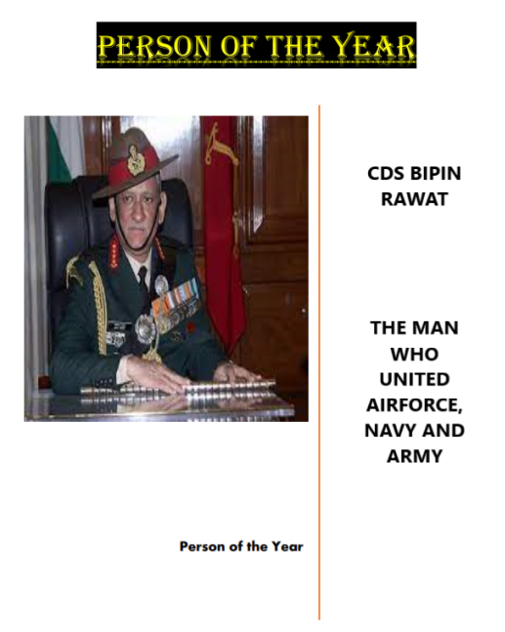

Person of the Year- “GENERAL BIPIN RAWAT”

Rawat’s tenure as Army chief coincided with India’s political leadership adopting a more muscular policy against Pakistan. The stand-off with China at Doklam on the LAC also took place under his watch. At the time he was among the first to speak openly about the possibility of India facing a “two-front war”. He courted controversy both as Army chief and as CDS when he waded into matters outside the remit of his office. His remarks against the protests over the citizenship law amendments, comparison of migration into Assam as an act of Bangladesh seeking lebensraum, his approval of lynching as an acceptable way of dealing with terrorists in J&K, description of the Air Force as a “support arm” of the Army were regrettable.

As CDS, it fell to Rawat to draw up plans for the modernisation of the military and make it an efficient fighting force, a responsibility he took up with much enthusiasm as it was a cause close to his heart. However, the Integrated Battle Commands into which he wanted to reorganise the Army did not materialise, mainly due to costs. The proposal to eliminate the rank of Brigadier too got a cool reception. In the last few months, he was preoccupied with the challenge of “theaterisation” or “jointness” of the armed forces, envisaging five “integrated theatre commands” that would combine the tri-services instead of each force having several regional commands. Reforming a military is no easy task, but in the one year that remained of his tenure, he was determined to push them through.